Axios is a popular JavaScript library that is often used with React.js (and other JavaScript frameworks) to make HTTP requests to APIs or web services. It provides a simple and consistent way to send and receive data from servers. 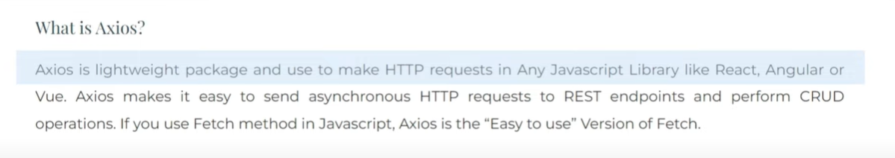

Axios Can call all HTTP Methods.

GET, DELETE, POST, PATCH all requests can be made with the help of Axios

In Simple words, Axios is the upgraded version of the fetch method or fetch API

Advantages of using Axios

Axios, by default, Work in JSON format. So, no more JSON parsing.

Make all types of HTTP requests (GET, POST, PUT, DELETE)

npm install axios

# Axios main purpose is to call the API

**1. What is Axios**

**2. Advantage of using Axios**

**3. Use Axios to react with Promises**

**4. Error Handling with Axios**

**5. Axios with Async Await**

**6. Best Way to Write Axios**

**To Create a React Application using a Vite**

** **cd foldername** to enter a folder

** **cd ..** to return 1 folder before

** for creating a folder in CMD **mkdir foldername**

**\* * ctrl + c to close the local Server Port**

**1.**

**npm create vite@latest axiosreactpractice -- -- template react**

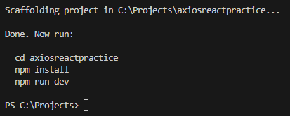

**Select Framework React for React Project, then Select**

**JavaScript + SWC**

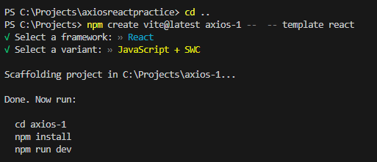

**Project Creation Completed**

**2.** Entering Project Folder **PS C:\Projects> cd axiosreactpractice**

**3. Then Write PS C:\Projects\axiosreactpractice> npm install**

**4. npm install completed**

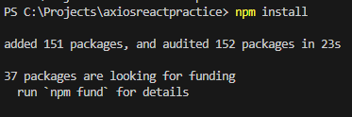

**5.** Then go [**https://www.npmjs.com/package/axios**](https://www.npmjs.com/package/axios) and copy

**npm i axios and install it**

**6. cls to clean the terminal**

**7**. **PS C:\Projects\axiosreactpractice>** **npm run dev**

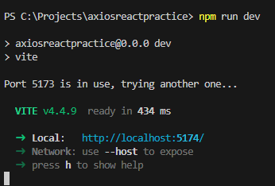

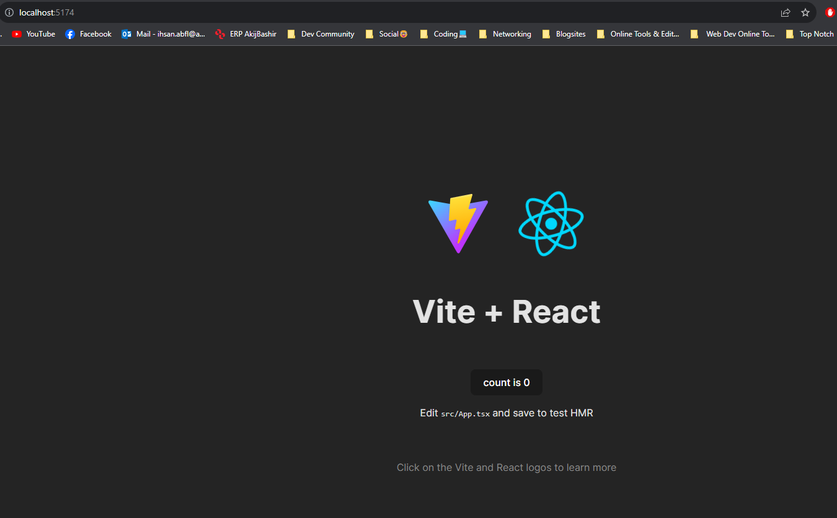

**8.** To Open in VS Code

**PS C:\Projects\axiosreactpractice>** **Code .**

**9.**